**COMSATS University Islamabad (CUI)**

**Project Proposal**

**For**

**PIXIE the Robot**

Version 1.0

***By***

**Sufi Hassan Asim CIIT/FA21-BAI-009/ISB**

**Hassan Ali Sajid CIIT/FA21-BAI-010/ISB**

***Submitted to*Dr. Akber Abid Gardezi**

**Table of Contents**

**Project Category** 3

**1.** **Abstract** 3

**2.** **Problem Solution/Objectives of the Proposed System** 4

**2.1.** **Objectives:** 5

**3.** **Related System Analysis/Literature Review** 6

**4.** **Vision Statement** 6

**5.** **Scope** 7

**6.** **Modules** 7

**Module 1: Central Human Interaction** 7

**Module 2: Emotional Intelligence** 7

**Module 3: Management Portal** 8

**Module 4: Entertainment Module** 8

**Module 5: Personal Assistant** 8

**Module 6: Maintenance Module** 8

**Module 7: Security and Privacy** 8

**Module 8: Mobility and Navigation Module** 9

**Module 9: Personalization Module** 9

**Module 10: Accessibility Module** 9

**7.** **System Limitations/Constraints:** 9

**8.** **Tools and Technologies** 10

**9.** **Project Stakeholders and Roles** 11

**10. Module based Work Division** 11

**11.**  **Mockups** 12

**12.** **References** 14

# **Project Category**

□ **A-**Desktop Application/Information System □ **B**-Web Application/Web Application based Information System □ **C-Problem Solving and Artificial** **Intelligence** □ **D-**Simulation and Modeling **□ E-Smartphone Application**

□ **F-**Smartphone Game □ **G-**Networks □ **H-Image Processing**□ Other (specify category) ________________

# **Abstract**

The Pixie Desktop Robot project focuses on the creation of a novel personal assistant, which is a unique blend of advanced AI and emotional intelligence needed to offer a friendly and experiencing experience to the user. This document underpinned by the project objectives describes the scope, tools and technologies, system limitations and competition analysis. The project's gamut includes individualized communication features that enable users to carry out tasks and integrate with smartphones. Among the objectives are improving user engagement, strengthening market competitiveness, and making the software systems available to all users regardless of the demographics. The choice of tools and technologies are: Python programming language, TensorFlow machine learning framework, and Google Cloud Speech-to-Text API. The statements in which privacy issues and other regulatory restrictions are mentioned are also considered. Besides, a competitive analysis also draws attention to competitors' weaknesses and solutions for them. To this end, the Pixie Desktop Robot project, by providing its users with an extremely intuitive, flexible, and emotionally intelligent personal assistant, will set the new standard in the modern personal technology sphere.

1. **Problem Statement**

Though technology is commonly found everywhere in our digital era, the connection between people and the devices is still electronically functional and impersonal. With the advancement of technology and its usage, humans start to expect these devices to provide more complex ways of showing emotions and needs. Nowadays, most personal assistants and smart home devices are equipped with various features that start from scheduling to looking for information, but they still fail to mimic human-like understanding by offering emotional intelligence and personalized conversations.

This lack of true interaction with the device creates a void where the users, especially those who work in high-tech environments often interact with, technically I can say, the device that doesn’t respond to their emotional cues, thus causing the user experience to feel disjointed and impersonal. If we take a look at highly skilled professionals and tech enthusiasts who spend hours upon hours with their technology, they might get a feeling of isolation and negative feelings as their tools do not have any emotions and do not adapt to the changing mental state of a person.

On the other hand, the technologies existing today fail to offer personalized interactions which can change their form based on the user's ongoing circumstances or emotional condition. They follow pre-set directions and being unable to learn from the previous dialogues, cannot do better next time. By generalizing the user base, this plan ignores people who have different preferences and uses all existing behaviors and interactions, which then lead to a user interface that is dull and annoying.

Thereby, highlighting a lack in the existing systems which requires a cutting-edge technological solution being a platform can understand and adapt to the user’s emotional and contextual facets, and thus redefining the human experience with the machines to be a personalistic and natural one.

# **Problem Solution/Objectives of the Proposed System**

The system is proposed for the Pixie Desktop Robot, a device that seizes the gap when people expect emotional and graduated communicative interactions with their personal digital assistants. The main purpose of the new solution is to develop a robot which not only handles routine functions but gives attention to the emotional wellbeing of its inhabitants by means of empathetic interactions and flexible responses. For the purpose of that, the robot is going to introduce artificial intelligence technology that can recognize and respond to human emotions so that the user experience is close and friendly.

We have the ultimate objective to develop a system that can be easily installed by users to their existing digital ecosystem making it easier for them to operate their smart homes without any challenges. The integration will further encompass recognizing environmental and contextual situational clues in order for Pixie to adjust its functionalities to those specific needs. Personalization as one of the major objectives is very fundamental in this case which allows the robot to learn from the interaction with the users and adapt its behavior to their preferences and mood.

Similarly, inclusiveness in providing access for a wide range of consumers, even those with disabilities, has to be a proximate need in the technology expansion in order for it to be beneficial to all. The concept will put user privacy as its top priority, along with data security measures, such as strong encryption and secure data handling process that allow the users to handle their own information. Furthermore, the system will be constructed with sustainability being primary consideration, an ambition that will see a focus on energy efficiency and reduced environmental impact. Lastly, the robot's architecture will be made with continuous learning and scalability in mind, which means that the robot will be able to receive further enhancements and the inclusion of new services or functions.

These goals are essential for the creation of the Pixie Desktop robot which is not going to be just a mechanical assistant, but a companion and a friend that will empathize with a person and will be useful in both personal and business environments.

## **Objectives:**

BO-1: Increases the user satisfaction with the customer care by creating an emotional and personal relationship.

BO-2: Lead your enterprise to front-rank status and make it more competitive through novelty and new personal robotic products.

BO-3: The premium user experience along with the lasting customer engagement would help influence and finalize the brand reputation and loyalty.

BO-4: Accelerate sales by boosting our brand among consumers and companies to capture a even bigger market share of the personal robotics market.

BO-5: Efficient energy utilization and less complicated manufacturing processes should be the two primary areas where operational costs can be lowered.

BO-6: Engage with wider market by extending footprint to multiple user age groups and accessibility criteria.

BO-7: Builds up strategic partnering to speed up product development and makes way for market penetration.

BO-8: Initiate Pixie in the front line of the futuristic specialty of emotional robot intelligence.

BO-9: Endue a high level of regulatory compliance, as well as ethical standards when designing a product and its deployment.

BO-10: Sustainable growth will be attained by continually adopting the market-oriented innovations and customer-centric service designs.

# **Related System Analysis/Literature Review**

|  |  |  |
| --- | --- | --- |
| **Competitor** | **Weakness** | **Proposed Solution** |
| CompanionBot | The lacking of emotional intelligence and mind adaptability as well. | Increase emotional intelligence algorithms responses and adaptive learning features to implement better engagement and satisfaction. |
| RoboAssistant | Lack of personalized interactions | Develop personalized and interactive features based on user behavior and preferences to keep up with user-specific interests to increase engagement. |
| TechCompanion | High cost and complexity | Create a newer optimized and user-friendly Pixie, which is going to have the same qualities and capability. |
| EmotiBot | Multiplying of scalability for different user’s needs without having enough requirements in place for performance and usability. | Make sure to make Design Pixie a user-friendly tool that is also highly customizable and can be used by different people with different preferences and accessibility needs. |

# **Vision Statement**

For the tech hobbyist and the professionals who want a companion at the workstation that responds to them, and provides a rich experience, the Pixie Desktop robot with smartphone integration can be a good and versatile desktop robot. It promotes personal contacts, replaces the obsolete habits, and gives amusement and encouragement to users. Unlike most of the existing personal assistants that are voice-powered without intuitive dialogue, our product can identify and adapt to the user’s moods or personality, becoming the irreplaceable partner at home and in the office.

# **Scope**

A wide range of functionalities focused on a user-friendly interface, emotional understanding, and environmental adaptability is implemented in the desktop robot Pixie as the main of the concept of the project. Pixie can become a multi-gateway that will connect you with work and home effortlessly, fitting into your daily life. The basic features of the proposed project can be represented as personalized interaction abilities, such as natural language and emotional recognition, through them Pixie can be able to engage users on a meaningful and feel free to share his or her frustrations manner. Extensively, Pixie will provide task automation capabilities and help users taking care of their repetitive tasks and arranging workflows which will contribute to productivity.

The project plan would also include a requirement to introduce continuous learning and improvement mechanisms and assure that the Pixie develops over time and better understands and serves its users. This, for example, involves the employment of AI algorithm algorithms, which then analyze the interactions and user feedback with the aim of improving Pixie's responses and additional functions. As an additional item, there is also a need to make provisions to safeguard data privacy and security with strong encryption method and consent mechanisms already put in place for the protection of user data.

In summary, Pixie Desktop Robot covers its area bound to a highly customizable, responsive, and secure personal assistant that raises the level of comfort in many daily life situations.

# **Modules**

## **Module 1: Central Human Interaction**

* **FE-1:** Voice command recognition and execution.
* **FE-2:** Gesture recognition and understanding.
* **FE-3:** Content response generation taken from the user service history.
* **FE-4:** Conversational AI that’s advanced for organic communication.
* **FE-5:** Mapping of multilingual speech recognition for NLP commands.

## **Module 2: Emotional Intelligence**

* **FE-1:** The analysis of voice and facial features for emotional mood detection.
* **FE-2:** Response adaption in accordance with one’s emotional state.
* **FE-3:** Synthetic emotions generation as a substitute for social interactions and their emotional responses.

## **Module 3: Management Portal**

* **FE-1:** Portal interface of admin for managing user's information.
* **FE-2:** Display the content gathered by the robot.
* **FE-3:** Account sign up / login for Pixie user customization purposes.

## **Module 4: Entertainment Module**

* **FE-1:** Multimedia management including for audio and video play back.
* **FE-2:** Storytelling capabilities with voice modulation.
* **FE-3:** Interactive content delivery of educational guidelines.
* **FE-4:** Music and video recommendation system based on user preferences.

## **Module 5: Personal Assistant**

* **FE-1:** Calendar management and event scheduling.
* **FE-2:** API integration for real-time data fetching (weather, news).
* **FE-3:** Email filters and voice-to-text functions.
* **FE-4:** The creation of a notification system for reminding and for important events
* **FE-5:** Shopping list and to-do list management.

## **Module 6: Maintenance Module**

* **FE-1:** Automating the process of evaluating system health
* **FE-2:** UI (User Interface) specifically design for Manual System Checks.
* **FE-3:** Log file generation and error reporting.

## **Module 7: Security and Privacy**

* **FE-1:** Biometric security measures (face recognition, voice recognition) will be used.
* **FE-2:** Embedding of end-to-end data encryption for data privacy.
* **FE-3:** Safe user authentication tools should be implemented.

## **Module 8: Mobility and Navigation Module**

* **FE-1:** indoor navigation systems.
* **FE-2:** Real-time obstacle detection and collision prevention
* **FE-3:** manual override controls.

## **Module 9: Personalization Module**

* **FE-1:** Themes could be customized to the extent, for instance, visually and audially.
* **FE-2:** Voice modulation tools that designed for voice modification such as pitch, rate, and accent.
* **FE-3:** Interactive avatars with customizable styles.

## **Module 10: Accessibility Module**

* **FE-1:** High-contrast and large-text options for visual accessibility.
* **FE-2:** Sign language recognition
* **FE-3:** Random check-in sessions accompanied by simple interaction questions and current status updates.
* **FE-4:** Have emergency detection and response system that would inform contacts or services.

# **System Limitations/Constraints:**

LI-1: However, Pixie's artificial emotional intelligence capabilities may sometimes lack precision to correctly translate emotions. Such imprecision can result in inaccurate emotions guessing or miscommunication.

LI-2: Possibly, the narrowness of emotional intelligence fundamentals may be the shortcoming of learning by Pixie that is not versatile enough for a variety of users and diverse moods.

LI-3: The resources available such as computation power and memory may set the scope of how Pixie efficiently answers questions, provide insights and advice.

LI-4: The productivity of Pixie adding automation to diverse user tasks involving complex environment can be hampered by both the variability and unplanned nature of the tasks and environments.

LI-5: Privacy worries about the level of user data collection and data analysis that Pixie can make in order to achieve its efficiency and success may happen as a result of.

LI-6: However, the scalability of that Pixie could be limited by traits such as server capacity and network bandwidth especially when huge number of users try to access it.

LI-7: Some regulations and legal standards, as data protection laws and industry norms, hinder the development and deployment of Pixie systems, as they prevent the development of these mechanisms.

LI-8: The extent of Pixie's accessibility features may be constrained by several elements including the compatibility of those features with different devices and the interface design which may limit the kinds of users who will benefit from those facilities.

LI-9: Beyond the essence of technical expertise and resources put to use for the endurance of future updates and enhancing Pixie's functionality, factors that may hamper sustainability might be blogged.

# **Tools and Technologies**

|  |  |  |
| --- | --- | --- |
| **Tools & Technologies** | **Version** | **Rationale** |
| Integrated Development Environment (IDE) | --- | Lightweight, cross-platform, and extensible IDE for efficient code editing and debugging. |
| Programming Language | --- | Widely used for AI, machine learning, and natural language processing tasks due to its simplicity and extensive libraries. |
| Version Control System | Git 2.33 | Distributed version control system for collaborative development and tracking changes. |
| Database Management System | --- | Lightweight and serverless database for storing user data and preferences locally. |
| Speech Recognition API | Google Cloud Speech-to-Text | Accurate and scalable API for converting speech into text, enabling voice interaction capabilities. |
| Natural Language Processing (NLP) Library | spaCy 3.1 , APIs | Efficient and user-friendly NLP library for advanced text processing and analysis. |
| Emotion Recognition Library | OpenCV 4.5 , APIs | Powerful computer vision library for real-time facial expression recognition and emotion detection. |
| Machine Learning Framework | TensorFlow 2.5, APIs | Flexible and scalable framework for developing and deploying machine learning models, including emotion recognition models. |
| Front-end Framework | --- | Declarative and component-based JavaScript library for building interactive user interfaces. |
| Back-end Framework | --- | Lightweight and easy-to-use Python web framework for building APIs and web applications. |
| Cloud Services | Amazon Web Services (AWS) | Scalable cloud infrastructure for hosting and deploying the Pixie application with high availability and security. |

# **Project Stakeholders and Roles**

|  |  |
| --- | --- |
| **Project Sponsor** | * COMSATS University Islamabad |
| **Stakeholders** | * Sufi Hassan Asim (FA21-BAI-009) * Hassan Ali Sajid (FA21-BAI-010) * Dr. Akber Abid Gardezi * Evaluation Committee |

# **10. Module based Work Division**

|  |  |  |
| --- | --- | --- |
| **Student Name** | **Student Registration Number** | **Responsibility/ Module / Feature** |
| Sufi Hassan Asim | FA21-BAI-009 | Module 1- Module 5 |
| Hassan Ali Sajid | FA21-BAI-010 | Module 6- Module 10 |

# **Mockups**

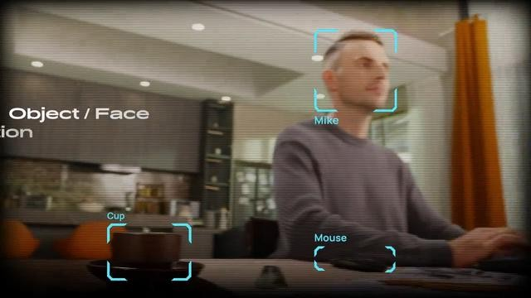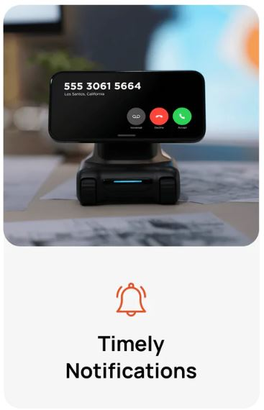

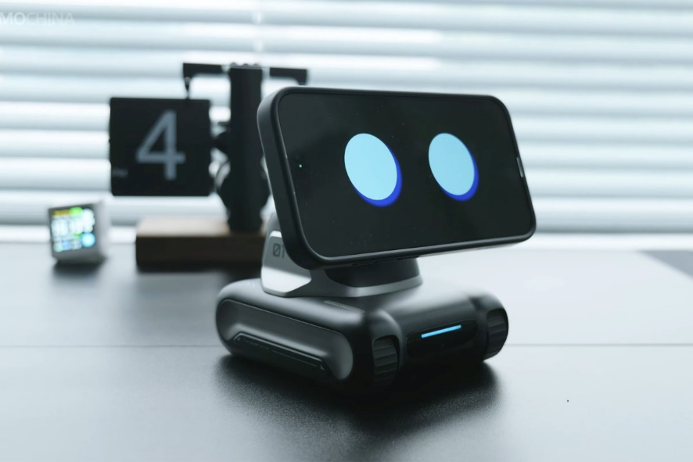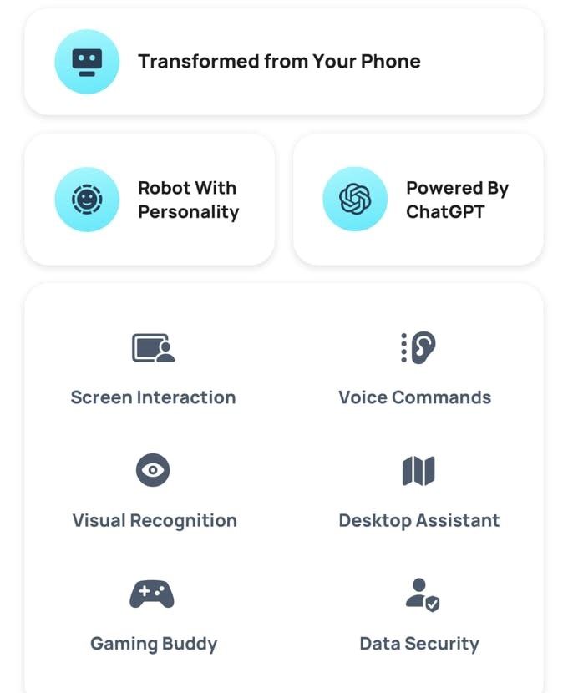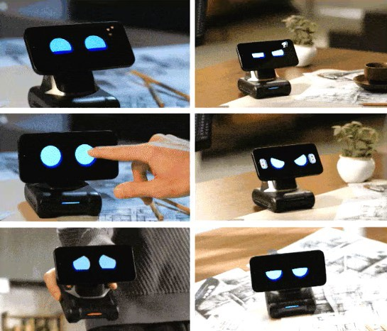

# **References**

Bird, S., Klein, E., & Loper, E. (2009). Natural Language Processing with Python. O'Reilly Media.

Géron, A. (2019). Hands-On Machine Learning with Scikit-Learn, Keras, and TensorFlow. O'Reilly Media.

Goodfellow, I., Bengio, Y., & Courville, A. (2016). Deep Learning. MIT Press.

Grinberg, M. (2018). Flask Web Development. O'Reilly Media. Available at: https://www.oreilly.com/library/view/flask-web-development/9781491991725/

Humble, J., & Farley, D. (2010). Continuous Delivery: Reliable Software Releases through Build, Test, and Deployment Automation. Available at: <https://www.oreilly.com/library/view/continuous-delivery/9780321670250/>

Shanmugamani, R. (2019). Deep Learning for Computer Vision. International Journal of Engineering and Advanced Technology, 8(5), 1100-1107.

Amazon Web Services. (n.d.). AWS Certified Solutions Architect Official Study Guide: Associate Exam. Retrieved from https://aws.amazon.com/certification/certified-solutions-architect-associate/

Keras Documentation. (n.d.). Retrieved from https://keras.io/

TensorFlow Documentation. (n.d.). Retrieved from https://www.tensorflow.org/api_docs

OpenAI API Documentation. (n.d.). Retrieved from https://beta.openai.com/docs/

Python Software Foundation. (n.d.). Python Language Reference. Retrieved from https://docs.python.org/3/reference/